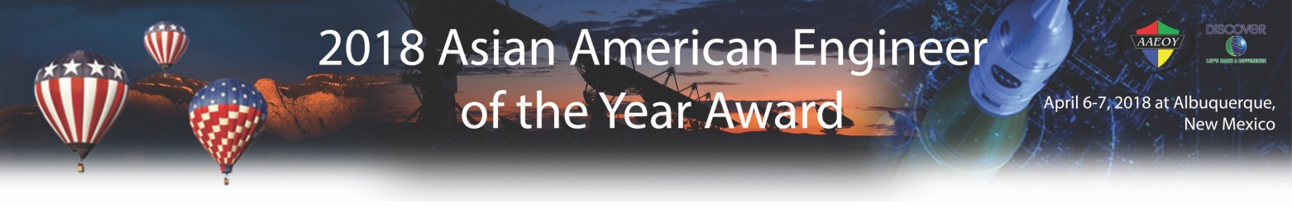

2018 AAEOY Sponsorship Agreement Form

Company/Organization Name:

Agrees to sponsor the Asian American Engineer of the Year Award and Conference as part of the DiscoverETM celebrations hosted by CIE/USA on April 6-7, 2018 at Hotel Albuquerque, 800 Rio Grande Blvd NW, Albuquerque, NM 87104. We are very pleased to support this prestigious event and will make the following sponsorships as indicated below:

Sponsorship Level | Unit Price | Quantity | Sub-total
Diamond Sponsor  - Up to three honoree nominations  - Two banquet tables for 20 guests  - One promotion page in the award program book  - Sponsor for one of AAEOY events (VIP reception, press reception dinner, technical seminars, or cultural tour). | $30,000 |  | $
Platinum Sponsor  - Up to two honoree nominations  - Two banquet tables for 20 guests  - One promotion page in the award program book | $25,000 |  | $
Gold Sponsor  - One honoree nomination  - One banquet table for 10 guests  - One promotion page in the award program book | $15,000 |  | $
Silver Sponsor  - One honoree nomination  - One banquet table for 10 guests  - One half-page promotion in the award program book | $10,000 |  | $
One page promotion Ad | $2,000 |  | $
Half page promotion Ad | $1,500 |  | $
One banquet table for 10 guests | $1,000 |  | $
Grand Total: |  |  | $

Signature: Date:

Name (please print): Title:

Phone: Fax: E-Mail:

Notes: Please complete and e-mail this form to sponsorship@aaeoy.org by October 16th, 2017.

